**MY BUSINESS VENTURE**

A coffee blog devoted to coffee news and culture, and will get everything from updates on new coffee shop openings to coverage of coffee culture in far-off places. The site which I run is called Coffee Love – Where Coffee Lovers Meet, we round up coffee news from around the web all in one place. It’s a great resource if anyone wants to know what's happening in the world of coffee, and who is writing about it. It's more geared toward the average coffee drinkers than the coffee professionals, but it's full of news related to the coffee world. As the name itself suggests, the blog is for all the coffee lovers out there. The name kind of says it all for this design-focused coffee site that publishes articles, guides, and reviews to all kinds of things in the coffee world. This blog is all about informing people about coffee. There is a wealth of information here, from consumer reviews to guides to sustainable coffee. If anyone ever have a question about coffee, this is the place to ask it.

The goal of Coffee Love is to help readers navigate the world of coffee. It covers coffee recipes, new cafes, coffee products and thorough reviews of coffee beans from around the world, and more. From coffee brewing tips to famous coffee quotes, our goal is to immerse everyone in the world of coffee. I’ll try to help the ordinary folks find and make great coffee as well. The blog covers a wide range of topics that coffee lovers of different backgrounds and experiences will find interesting. The site’s content is by no means limited to this. Basically, anything and everything that has to do with coffee is published. I plan to cover coffee experiment and brewing guide too. Hopefully, in the near future I may set up a small coffee shop (physical store). So the whole concept of Digital Marketing might help my future business venture.

**THE BUSINESS OBJECTIVE**

The primary objective is to educate my blog readers on what I do. Well before I actually start setting up my coffee shop, I want to build a brand. The quest for invention brings about creativity. Marketing pulls while sales pushes. Undoubtedly, it is almost impossible for any business to survive without the duo of sales and marketing. However, marketing could at times pose intimidating challenges if not well managed. In order to get the most from little or no effort (potential and established), creativity is needed. People visit their minds before visiting coffee shops. It is all about being convinced about what to meet whenever shops are visited. Coffee shops should not be about coffee sales alone but about varieties that best satisfies customer’s intentions. Quality products, friendly service and competitive prices will always go a long way to cement the brand, but what is important is to stand out – which takes back to the original point and strive to be creative.

**BUYER PERSONA**

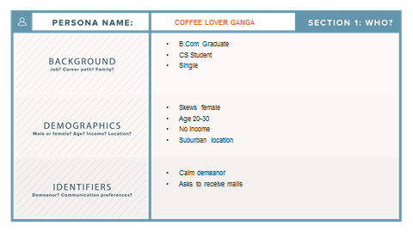

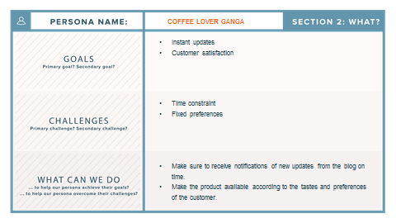

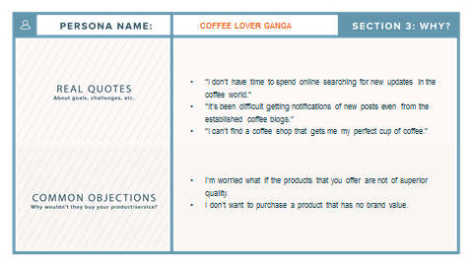

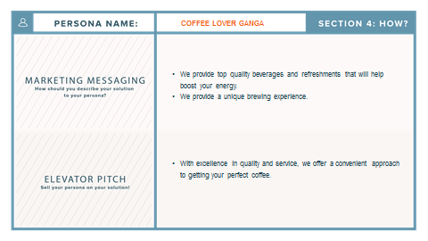

**GO TO MARKET STRATEGY**

By virtually connecting everybody to a social network, there is an incredible potential for the spread of my product and brand. Engagement with clients outside the store is difficult as a coffee shop because consumers don’t have that many reasons to connect online, unless incentives are used. Just being present online is not sufficient for me because everyone can be.

That’s when there is a need to implement the right tools to attract and engage customers to the network. So why not make it a social one? Interact with customers, spread ideas, advertise promotions and explain how they benefit from being connected to the network. That’s how I ended up creating an FB page and a YouTube channel. It really worked for me.

Digital Marketing helped me in utilizing various social media platforms as marketing tools with the purpose of maximizing the reach of potential customers, receiving feedback on brand and product, and most importantly building relationships with clients well before them approaching my coffee shop.

**DIGITAL MARKETING**

One of the reasons why Digital Marketing is taking over Traditional Marketing channels is the ability of Internet Marketing Tools to interact with the targeted audiences in real time. Engagement in any form is what the customers expect to receive when interacting with the brand or business. How the business handles such engagements and interactions will spell the difference between business success and failure. Interacting and providing the customers with proper engagement points can give an insight of what the targeted audiences want. This vital information will steer the business towards making the right set of next moves, provide the customers with an even better experience, develop good relationships with them – gaining their loyalty and trust that will be needed when any business begins to grow.

The power of digital marketing lies in its ability for attracting targeted traffic. These types of audiences for the content are most likely ready to know more about the brand, products or services and may be interested enough to purchase what the business have to offer. Delivering on what the brand promised will help to develop a better relationship with the targeted audiences. The customers will come back and interact with the site some more – on a regular and continuous basis.

This may prove beneficial for my brand reputation, as satisfied customers will most likely tell other people about their experience with the brand, product or service. My brand reputation will go viral as expected, further opening new doors of opportunities for reaching bigger markets and attain business growth.

Digital Marketing leverages on social media signals, social proof and testimonials from actual consumers who have previously purchased, joined, or availed of a product or service marketed by a brand or business. The more reliable these social signals are, the higher the trust rate it can generate from targeted audiences – most of which can be potential customers.